|  |  |
| --- | --- |
| **To: Professor Darish** | **Date: 3/25/2015** |
| **From: Trever Wagenhals** | **Course & Section Number:** |
| **Subject: Transient Response DC** | **Partner(s):**  **TA:** |

**SUMMARY**

In this lab, capacitance and inductance were tested in a DC circuit to measure the transient response of the two. The voltage drop across a draining capacitance was tested and shown through the oscilloscope. Voltage drop and current across a RC circuit and RL circuit were tested to ensure that the calculations matched the measurements. Overall, all of the results fell within reasonable error of the calculations.

**EXPERIMENTAL APPROACH**

**Equipment and Materials**

* Oscilloscope
* Function Generator
* Protoboard
* Inductors, resistors, and capacitors
* Banana clips, BNC cables, probes
* Power supply

**Procedure**

This lab was broken down into 3 major parts. The first section involved a circuit with a steady state capacitor. With a switch in the system, the power supply could be removed from the circuit, causing the capacitor to leave steady state and begin to decay. Through the oscilloscope the voltage drop can be viewed and a visual comparable to the time constant decay can be shown.

The second section of the lab also had to do with the time constant, but instead involved using the mathematical equations to determine the time constant and compare that time constant to a square wave representation of the voltage change over time.

The last section of the lab involved an RL and determined whether the inductor acted as a short circuit when reaching steady state conditions.

**DISCUSSION OF RESULTS**

Based on the circuits shown in the designated figures, the calculations made based on the circuit, and the actual measured values, the capacitors acted exactly as anticipated, allowing the time constant to be obtained without question of error.

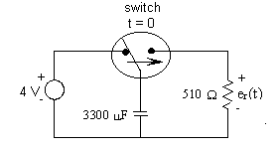Figure 10-2/10-3

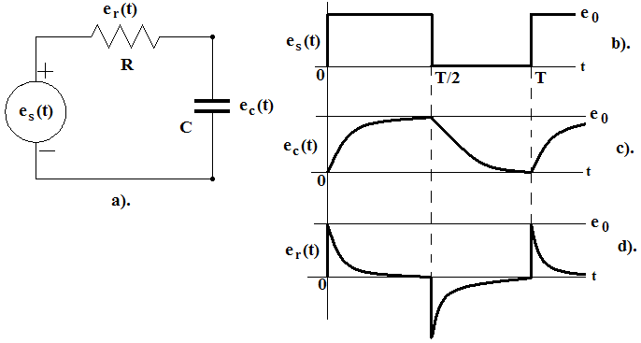

|  |  |  |  |
| --- | --- | --- | --- |
|  |  | For Fig. 10-2 | For Fig. 10-3 |
| Voltages | Calculation | V1 = 0V  V2 = 10V | V1 = 7.02V  V2 = 2.98V  V3 =2.98V |
| Measurement | V1 = 0V  V2 = 9.43V | V1 = 6.95V  V2 = 3.01V  V3 = 3.01V |
| Currents | Calculation | I = 0A | I = 5.8 mA  I1 = 5.8 mA  I2 =0 A |
| Measurement | I = 0A | I = 5.7 mA  I1 = 5.7mA  I2 = 0 A |

When the following circuits were tested and measured, the capacitor acted as expected, having no current flow through it because it acts like an open circuit.

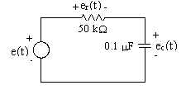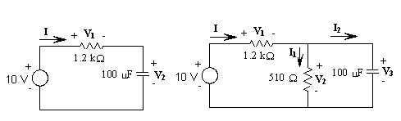

|  |  |  |  |
| --- | --- | --- | --- |
|  |  | For Fig. 10-5 | For Fig. 10-6 |
| Voltages | Calculation | V1 = 10V  V2 = 0V | V1 =10V  V2 =0V  V3 =0V |
| Measurement | V1 = 9.99V  V2 = 0.3mV | V1 =10V  V2 =0V  V3 =0V |
| Currents | Calculation | I = 0.2mA | I =8.3mA  I1 =0A  I2 =8.3mA |
| Measurement | I = 0.21mA | I =8.2mA  I1 =0A  I2 =8.2mA |

***4. Questions***

What happens to the energy stored in the capacitor?

The energy begins to deplete from the capacitor until it approaches 0 at a specific time constant relative to the resistor in the circuit.

How did you get the time constant of the circuit from your display?

Based on the chart of the capacitor decreasing, the boxes can be counted until the wave flatlines, and then the number of boxes can be multiplied by the time division to get the time constant.

How could you check that the capacitor in steady state is open circuit?

To check that the capacitor in steady state acts as an open circuit, place a multimeter between the circuit and the capacitor and measure the current. As the capacitor approaches steady state, the current will approach 0 A.

Compare V2 and V3. Explain.

V2 and V3 should have the exact same voltage drop, although there should be no current flow to V3. The voltage is because of KVL, while the current is because of the steady state of capacitors.

How could you check that the inductor in steady state is a short circuit?

If an inductor is in steady state, the total current from the rest of the circuit will flow through it. So, even if an inductor is in parallel with something else, the current will flow to the inductor. There will also be no voltage drop across it.

Compare I1 and I2 Explain.

\ I1 will have no current actually flow through it because the inductor will act as a short and allow all of the current to pass through it instead.



